# Exploring 1-Wire Devices revised 7/5/14

This document describes a method to interface the Dallas Semiconductor high-precision one-wire digital thermometer (DS18S20) device with the EVB001 evaluation board. The hardware and software interface, discussed in this app note, uses arrayFORTH and polyFORTH, respectively. This illustrates one way to prototype such an interface from the manufacturer's one-wire protocol documentation.

The text assumes you have familiarized yourself with our hardware and software technology by reading our other documents on those topics. The current editions of all GreenArrays’ documents, including this one, may be found on our website at <http://www.greenarraychips.com> . It is always advisable to ensure that you are using the latest documents before starting work

The work described herein is that of Franklin Amador.

**CONTENTS**

1 Introduction 2

2 The one-wire Interface 3

2.1 Interface Circuit 3

2.2 One-wire Protocol Overview 3

2.3 Sending Data 4

2.4 Receiving Data 6

3 arrayFORTH Implementation 8

3.1 The one-wire Kernel 8

3.2 Loading 9

3.3 Initialization 9

3.4 SoftSim Integration 9

3.5 Testing on the Chip 10

4 polyFORTH Implementation 11

4.1 Integrating the one-wire kernel 11

4.2 Accessing the one-wire kernel from polyFORTH 11

4.3 Integration into polyFORTH 12

4.3.1 Accessing GA144 node 12

4.3.2 ROM Search Algorithm 13

4.3.3 High Level one-wire polyFORTH Code 15

4.3.4 polyFORTH Example 1 16

5 Conclusions 17

6 References 17

# Introduction

This application note attaches a Dallas one-wire Temperature sensor (DS18S20) to the GreenArrays’ evaluation board (EVB001) using a simple custom level shifting circuit. An off-the-shelf level shifter solution was decided upon by using Texas Instruments TXS0102 chip which already contained the necessary pull-up resistors for the one-wire interface. However, due to the no-lead DQE package ordered, it was impossible to wire leads to the chip without fully designing a surface mount board. As a result, a simple proof-of-concept circuitry was created and bread boarded with readily available components from the local electronics stores.

The one-wire kernel only uses 1 of 144 nodes for sending and receiving bytes over the one-wire network. The code does not include CRC error checking, but could be added at a later time for real applications. This applications note shows the basic bare-bone mechanisms needed to both interface and communicate via one-wire bus.

This effort was possible through Brad Rodriguez’s one-wire high level Forth implementation on CamelForth [6] with GNU GPL v3 license; however, the one-wire library is now release under the BSD 3-Clause license [10] with a small optional donation for its use.

## Licensing

arrayFORTH’s one-wire kernel and polyFORTH’s interface to the arrayFORTH’s one-wire kernel for the GreenArray’s F18A © 2014 by Franklin Amador.

This program is free software; you can redistribute it and/or modify it under the terms of the GNU General Public License as published by the Free Software Foundation; either version 3 of the License, or (at your option) any later version.

This program is distributed in the hope that it will be useful, but WITHOUT ANY WARRANTY; without even the implied warranty of MERCHANTABILITY or FITNESS FOR A PARTICULAR PURPOSE. See the GNU General Public License for more details.

For a copy of the GNU General Public License, see <http://www.gnu.org/licenses/>.

# The one-wire Interface

The one-wire protocol is discussed in every one-wire datasheet [7] and fully detailed in the “Book of iButton Standards” AN937 application note [8].

## Interface Circuit

The interface circuit between the one-wire bus and GA144 chip is similar to SparkFun’s logic level Bi-directional converter (BOB-12009). However, the major difference is the pnp transistor used as oppose to the N-Channel MOSFET proposed by SparkFun. Lastly, the base current needs to also be limited as it can cause the circuit to overheat and burnout and an additional bypass diode was added since the transistor package did not include one.

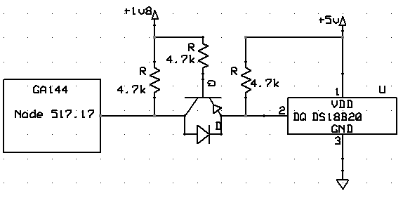

Powering the DS18S20 with an External Supply

The results from the digital switching between low level at 1.8Volts to high level at 5.0Volts worked as expected.

## One-wire Protocol Overview

The one-wire protocol runs on master-slave architecture with a minimum of 6 types of signals; reset pulse, presence pulse, write 0, write 1, read 0, and read 0. All communication is initiated with a Reset pulse from the master and then waits for a presence pulse from any slaves on the network. If no presence pulse is detected then no data is transmitted by the high level polyFORTH code.

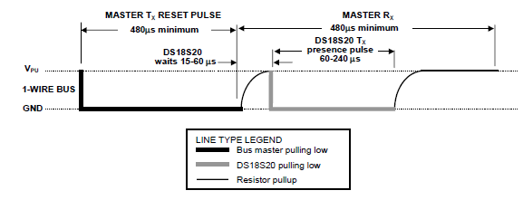

Initialization Timing

If a presence pulse is detected, then the master streams bytes of data at 1 bit per read/write time slots. Depending on the commands sent then 0 bytes, 8 bytes or 9 bytes are read back from the slave.

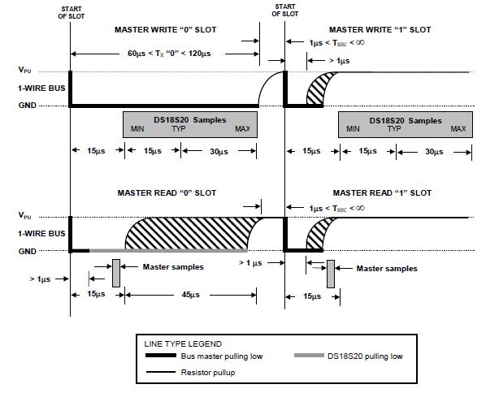

Read/Write Time Slot Timing Diagram

## Sending Data

Every one-wire device has a set of unique command protocols that pertains to that particular device. In this particular device, the DS18S20 has the following unique protocol commands.

Function Command Set Table

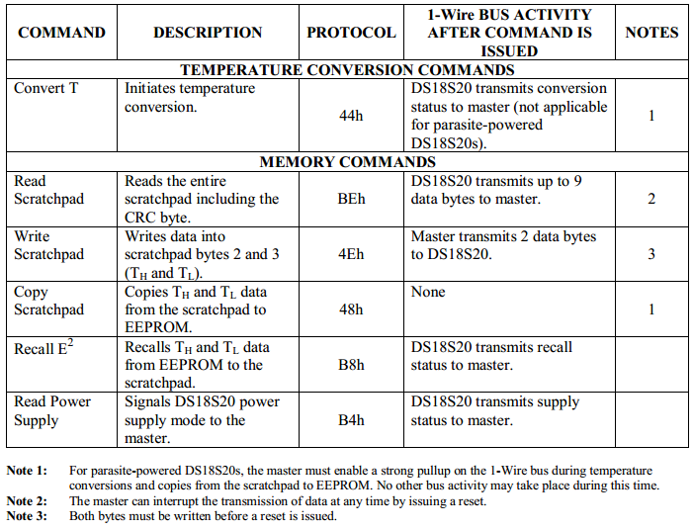

At this point, it is emphasized that the term one-wire becomes blurred when an additional strong pullup is needed when in parasitic wire mode. Without either a strong pull up or separate external volt supplied to the DS18S20 device, we cannot get temperature conversion or Copy from ScratchPad (Protocol 44h or 48h) functions to work properly.

Sending data is as simple as writing a “0” or “1” slot as shown on the previous page. During a send command, we write the sequential binary data starting from LSB to MSB in 8 bit intervals. While the Master node is in sending mode, the one-wire devices listen to the data being sent on the bus and do nothing with the bus. As a result, the bus shows just the data being sent from the master. In the example below the Master is sending a hex byte of 33h (00110011b).

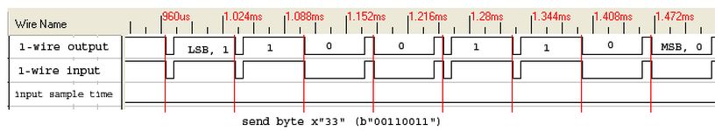

Sending Transmission Packet Timing

## Receiving Data

As the Master node is the one always initiating the transmission and receiving of data, the master has to first send bytes of ffh (11111111b) to sequence the data bits being sent back to the master from the slave. This lets the particular one-wire slave device synchronize when it’s time to send its own data bits.

In the particular case below, the master always sends ffh data and the slave device waits for the initial pull down of the line to send it’s 1s or 0s by either release or holding the bus line down respectively. Again, in the example below the Master is sending a hex byte of ffh (11111111b) and the slave is sending back a hex byte of 33h (00110011b). In the receiving data cycle, the master will wait a predetermined time (less than 15us) to sample the bus line for the bit state.

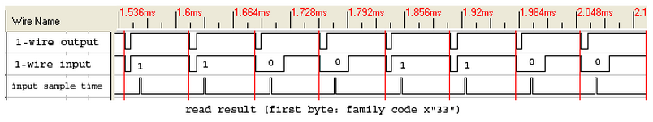

Receiving Transmission packet Timing

For a DS18S20 read scratch pad command (hex byte BEh) we’ll receive a total of 9 bytes of data as outlined below.

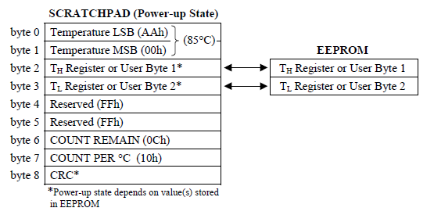

Receiving Scratch Pad packets frames

Bytes 0 & 1 are further detailed in the Temperature Register Format list below. The LS Byte bit 0 is the .5 degrees Celsius. The MS Byte is only used for signed information of Positive (S=0) or Negative (S=1) temperature values.

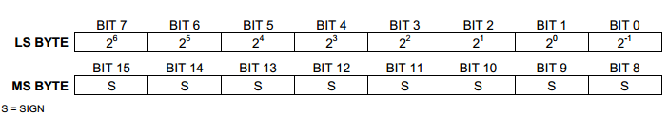

Temperature Register Format

The actual analog temperature scaling received from LSB (byte 0) and MSB (byte 1) is further defined in the Temperature/Data Relationship table.

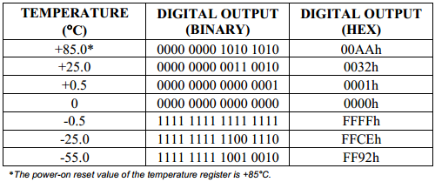

Temperature/Data Relationship

It is interesting to note that a Hex-to-Decimal conversion and multiplied with 5 will give the temperature in Celsius with the decimal point moved to the right (multiplied by 10) or if we divide by 2 or right shift one bit we also arrive at a non-decimal resolution.

For detailed temperature fractions readings other than a 0.5 resolution the COUNT REMAIN (byte 6) and COUNT PER C (byte 7) from the scratch pad reading can be used with the fraction equation below. However, the Temperature reading (byte 0) will need truncated to eliminate the 0.5 resolution prior to using the value as TEMP_READ.

*TEMPERATURE = TEMP_READ - 0.25 + (COUNT_PER_C - COUNT_REMAIN)/COUNT_PER_C*

Fraction Temperature equation

The table below outlines the possible values from 5 *, 2/, and Temperature conversion.



# arrayFORTH Implementation

One F18 computer (Node 517) with 49 words (31h) is used to implement the onewire – kernel in F18 code. No clock is needed for this application. The slaves basically wait until the master sends the necessary high/low commands for both synchronization and logic functions. Luckily for us, it is quite easy to figure out the right (200) delay with “**for . . unext**” commands to create an approximation to 1 usec. As a result, to approximate 500 usec we just multiply 500 with 200 to arrive at the necessary time delay that will be used in the kernel.

## The one-wire Kernel

Two important words are used for the kernel; 1) **reset** and 2) **slot**. Both words follow the timing diagram as shown on the one-wire protocol overview section 2.2.

The reset word is in charge of initializing the beginning of data transfer to/from the master/slave. It basically transmits a master reset and waits to receive a presence pulse from the one-wire network. As a result, a high signal results in no one-wire device present and a low signal results in a one-wire device present. This data is inverter as 0 for no device or -1 for one device present and the result is sent back to polyFORTH.

The slot word is in charge of the Master Write and Master Read for a given 1/0 slot. In the slot word, we first pull the line low for 6 usec and see if the bit to be sent will be a 1 or 0. If the bit is a 1 then we just hold the line high otherwise we keep the line low. Then we continue with a 16 usec delay and sample input pin and or the result with the original 8 bit word to bit position 9. Lastly, we right shift one bit, wait for 35usec, pull the line high and delay for 2usec. This function completes both the Master Write and Read 1/0 slot commands. Please note that during Master Write the pin is sampled to finally end up with the same 8 bit word we originally wanted to send and that we discard this word in polyFORTH.

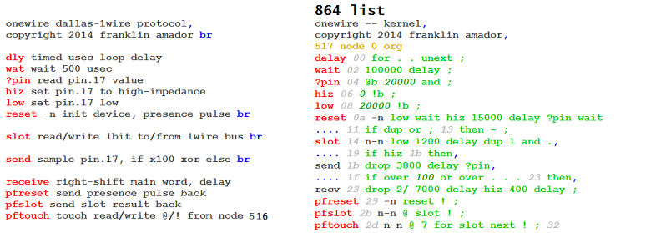

In the end, node 517 basically waits for commands from node 516 which has Glanglia code to send its data back to polyFORTH via Snorkel. These network commands are integrated in 1) **pfreset**, 2) **pfslot** and 3) **pftouch** where pf stands for polyFORTH. As you can see, **pfreset** just sends data back to node 516 once initiated. Also, both **pfslot** and **pftouch** receive data (via Fetch thru a register) to be sent on the one-wire bus and once done then it transmit data (via Store thru a register) back to node 516.

## Loading

A loading block is used to load the one-wire kernel. Block 200 must contain the instruction **862 Load**.

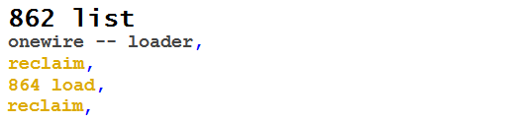

Loading Block

## Initialization

Block 860 is used for the node initialization. This can be either used for SoftSim, loading the code into the GA144 chip, or integrating it into PolyFORTH boot stream.

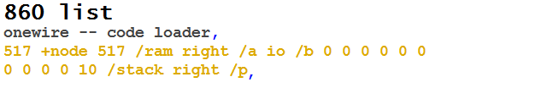

Initialization Block

**/stack** defines the values on the stack at chip initialization. This is helpful to load and not waste energy and pass the default ***15555*** stack data while the kernel is running. Notice that the communication port to node 516 is the right port. As a result, both the **/a** register and the **/p** register are loaded to look and wait for commands from polyFORTH at all times. The **/b** register is used to read/write to the node 517.17 pin.

## SoftSim Integration

If we want to test our interface with SoftSim then block 866 is used to define the environment.

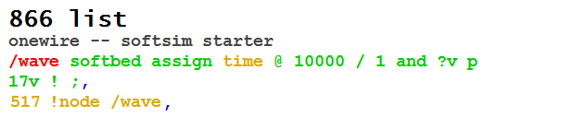

SoftSim Integration

A **866 load** must be placed in block 216 to include our example in SoftSim. The bus on Pin 17 is changed every 10000 ticks. Note, after using SoftSim and before using the code on the chip we must comment out the ***866 load*** command.

## Testing on the Chip

For testing on the host chip we create a block that loads the code onto the chip and another for interactive testing.

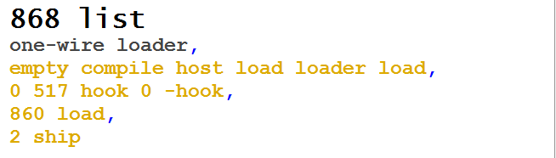

Loading code onto the chip

First we type **868 load**. After some time the code is loaded into the chip and started. Now we must use **858 load** to reset the chip and display the ROM/RAM.

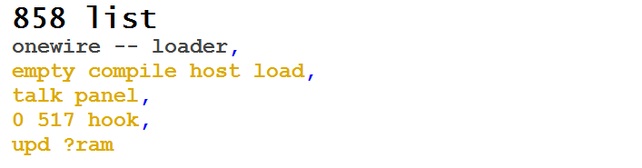

Resetting the chip and displaying ROM/RAM.

We should now see the following screen:

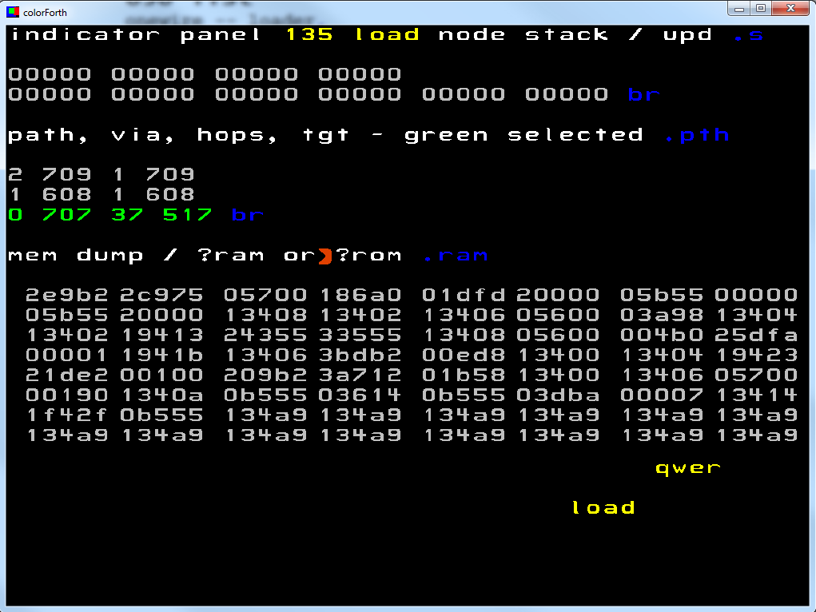

Interactive Panel IDE

# polyFORTH Implementation

For using the full potential of the one-wire interface, we can integrate it into a virtual machine that takes care of the higher level aspects. The larger memory of the polyFORTH virtual machine is better suited for configuring the one-wire and interpreting the response.

## Integrating the one-wire kernel

If we want to load our one-wire kernel code together with the polyFORTH virtual machine, then we can place a **860 load** into block 368 (or 478 for older versions), where the additional I/O for the virtual machine is loaded:

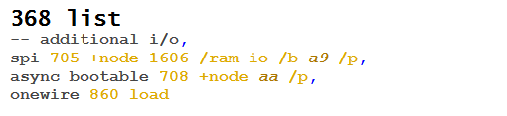

Listing 12 Integrating our code into the polyFORTH boot stream

When polyFORTH is started then our code will also be loaded into node 517. That is true whether you start polyFORTH from the IDE (450 load) or you install the polyFORTH boot stream in the flash (460 load).

## Accessing the one-wire kernel from polyFORTH

After starting polyFORTH on the evaluation board, we load the snorkel and ganglia mechanism by doing a **142 load** command.



arrayFORTH’s block 142

## Integration into polyFORTH

Until now we have used our one-wire interface with arrayFORTH. In order to fully support the one-wire protocols and its features we must implement a little driver that converts the one-wire commands to Read/Write bytes. To simplify the task we load block 300 for loading the one-wire driver.

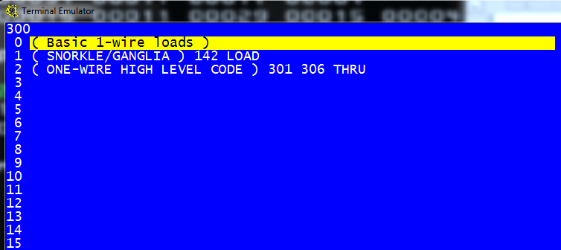

One-wire loading

### Accessing GA144 node

Block 301 defines the words (OWRESET, OWSLOT, OWTOUCH, OWPUT, and OWGET) for actually accessing the one-wire kernel read and write to 517.17 io pin.

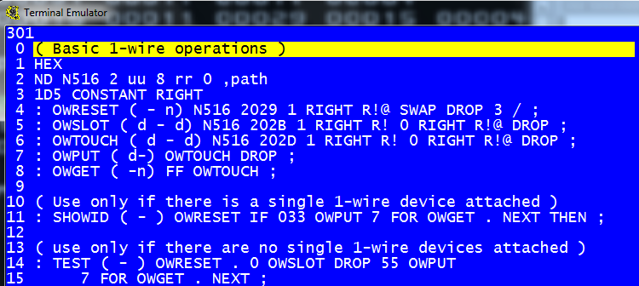

polyFORTH Block 301

Note that we first define a path to Node 516 which will finally talk to Node 517. The wire path to Node 516 uses Snorkel and Ganglia via the polyFORTH virtual machine. Then we further re-define each one-wire words in Node 517 for polyFORTH VM interpretation. I leave it to the reader to study Application Note 009 for other existing examples of using Node 142 for R!, R@ and R!@ commands.

### ROM Search Algorithm

To search for available devices over the one-wire bus, Dallas Semiconductors has provided a search algorithm outline on their Book for iButton Standards [8] Figure 5-3.

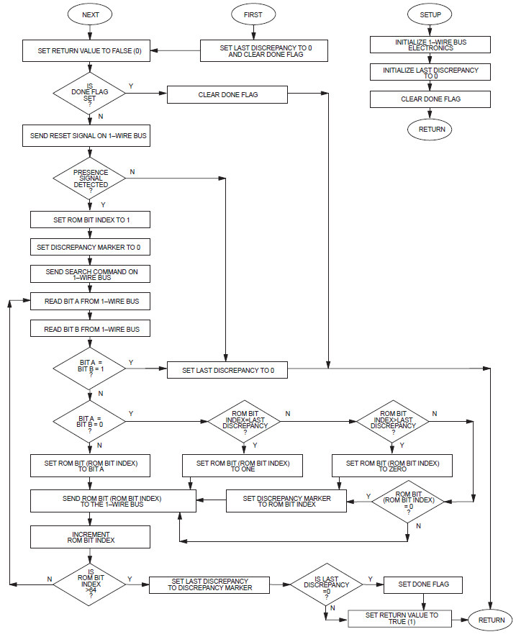

ROM Search Algorithm

Blocks 302, 303 and 304 referenced below are used from 4e4th one-wire implementation by Brad Rodrigues [6]. What is not included in [6] are the LSHIFT and RSHIFT commands that I implemented in polyFORTH.

Block 302 defines the all the variables bytes for the ROM Search Algorithm. Here we also define missing Left Shift (LSHIFT) and Right Shift (RSHIFT) from the polyFORTH VM.

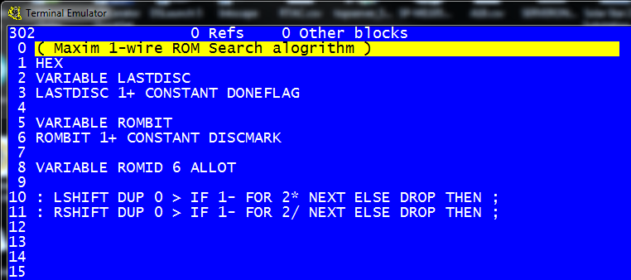

polyFORTH Block 302

Block 303 defines the ROMBIT fetch and store routines and reset of

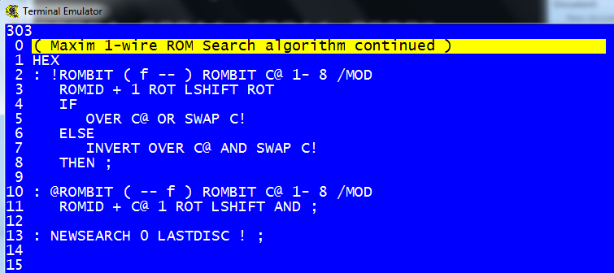

polyFORTH Block 303

Block 304 defines the ROM SEARCH algorithm [8] as outlined by the logical diagram Figure 5-3.

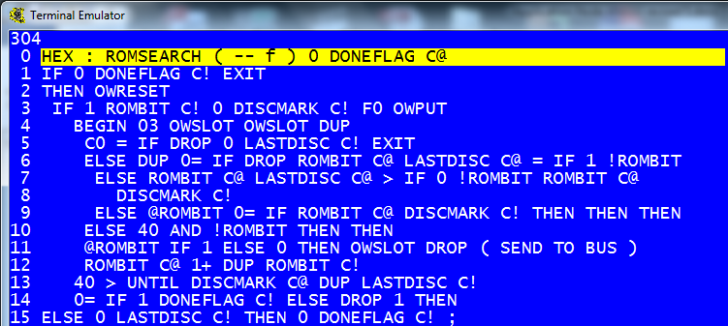

polyFORTH Block 304

### High Level one-wire polyFORTH Code

Block 305 finally defines the last of the high level polyFORTH interface to the one-wire protocol. The SHOWIDS uses the ROMSEARCH algorithm to display any device ID on the network. SENDID focuses on that particular device for further commands. READSCRATCH, OWCONVERT and READTEMP are specific to the DS18S20 temperature device.

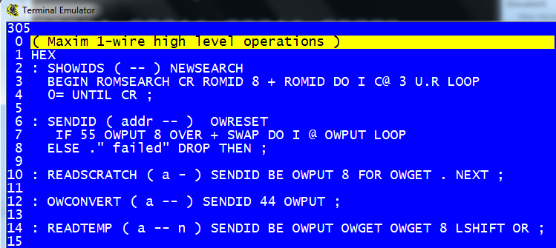

polyFORTH Block 305

Although NOT coded verbatim from reference [6], the “TEMP>PAD” is now refined for this polyFORTH implementation.

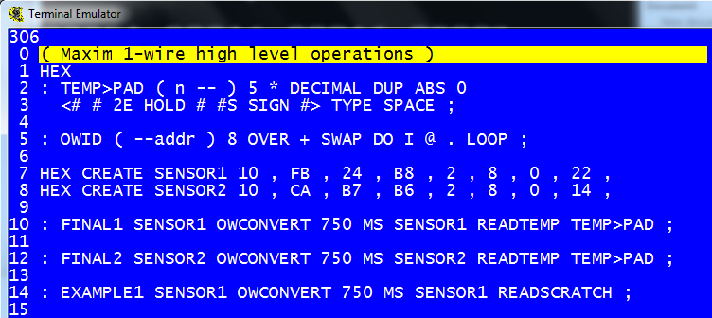

PolyFORTH Block 306

It’s my hope that in a future Application Note that I can implement a Floating Point library for polyFORTH.

### polyFORTH Example 1

The following sequence of steps are coded block 306 as the define EXAMPLE1 polyFORTH word. As you can see, the simplicity of Forth is apparent when viewed in the top down hierarchical forth word command arrangements.

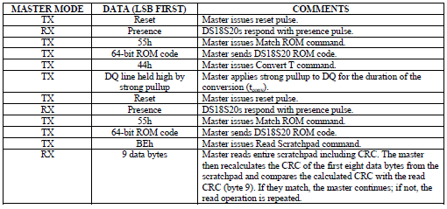

Below are some of the working commands for the one-wire protocol. The first command “SHOWIDS” will query the one-wire bus for available devices. I had a bug in the ROMSEARCH algorithm that took more than one time to actually get all the devices ID, but this is now corrected. In my particular one-wire network I only have two DS18S20 devices.

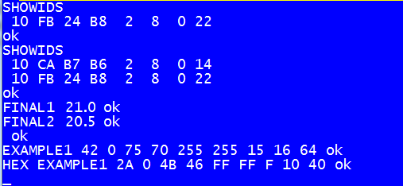

Working One-wire commands

Lastly, we show the “FINAL1” & “FINAL2” working words that receives the temperature of both devices in degrees centigrade, respectively. Lastly, we show the data received back from the example 1 above. The scratchpad data from Sensor1 displays all the available information as described section 2.4.

# Conclusions

We have shown how to interface the Dallas Semiconductor one-wire master protocol in the multi-computer architecture of the GA144 chip. Combining F18A machine level language using arrayFORTH and high level polyFORTH virtual machine gives any novice or experienced developer the flexibility to design both in Hardware and Software. It is further emphasized that the one-wire kernel, although considered a slow protocol by GreenArrays standard, was implemented using a mere 50 words on 1 out of 144 nodes.

The author of this document is a system integrator for a controls engineering company. This is the author’s 1st attempt at implementing forth in any application. With the help of the documents and staff from GreenArrays it was possible to write the driver software in a few weeks. Although arrayFORTH and polyFORTH are very different than environments most programmers are used to, GreenArrays tools were complementary to its architecture 1) simple and 2) modular.

This application note was finished at nights while carrying the author’s 9 month year old on a baby carrier. The author wants to thank for the help and patience he received from the GreenArray staff, Charley Shattuck.

# References

[1] “ArrayFORTH User’s Manual, for G144A12 and EVB001”, Green Arrays DB004

[2] “polyFORTH Reference manual”, GreenArrays Data Books: DB005

[3] “G144A12 polyFORTH supplement to DB005”, GreenArrays Data Books: DB06

[4] “F18A Technology Reference”, GreenArrays Data Books: DB001

[5] “Attaching a PS/2 Keyboard”, GreenArrays App Note: AN009

[6] <http://www.camelforth.com/download.php?view.27>

[7] <http://datasheets.maximintegrated.com/en/ds/DS18S20.pdf>

[8] <http://pdfserv.maximintegrated.com/en/an/AN937.pdf>

[9] <http://en.wikipedia.org/wiki/1-Wire>

[10] <http://www.camelforth.com/news.php>